Step 1 – Adding data source

This can done either in seal report designer or seal server manager.

In server manager the following steps are to be followed

File -> New -> SQL Data source

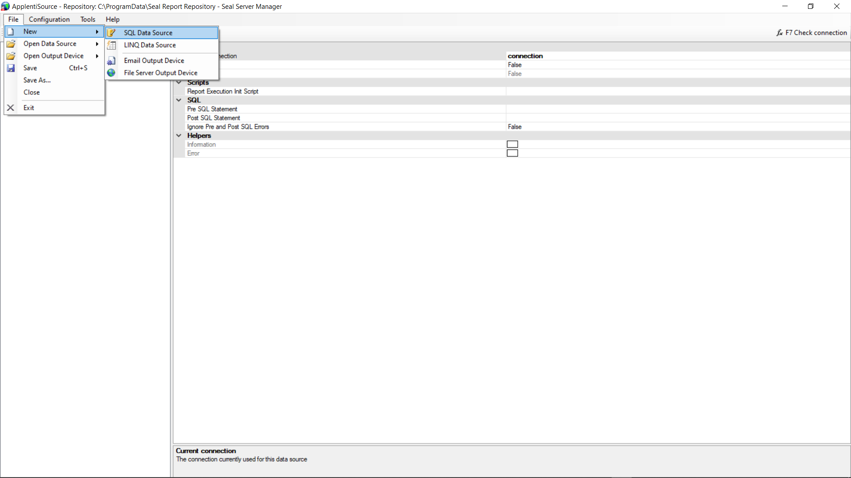

We get the following page after we create our data source.

After a Data source is created, we can add connections to the Database, Add tables, Specify the Joins that we may require and Different types of Enumerated Lists that we can use.

To add a connection, Under the Data source that we created, in Connections -> connection we can set the following values and these values depend on the type of database server i.e. whether it is MS SQL Server or OLE DB etc.

Database type -> ‘MS SQL Server’

Connection type -> ‘MS SQL Server’

MS SQLServer connection string -> Server=tcp:applenti-dev.database.windows.net,1433;Database=Enterprise360-Dev;User ID=enterprise360-dev;Password=3MBzrk!tk#ymnxkFXeBNf2pZY%J8E!FQMkVyS7u8GrqevBsxattEvaqtbxAESz^R;Encrypt=True;TrustServerCertificate=False;Connection Timeout=30;

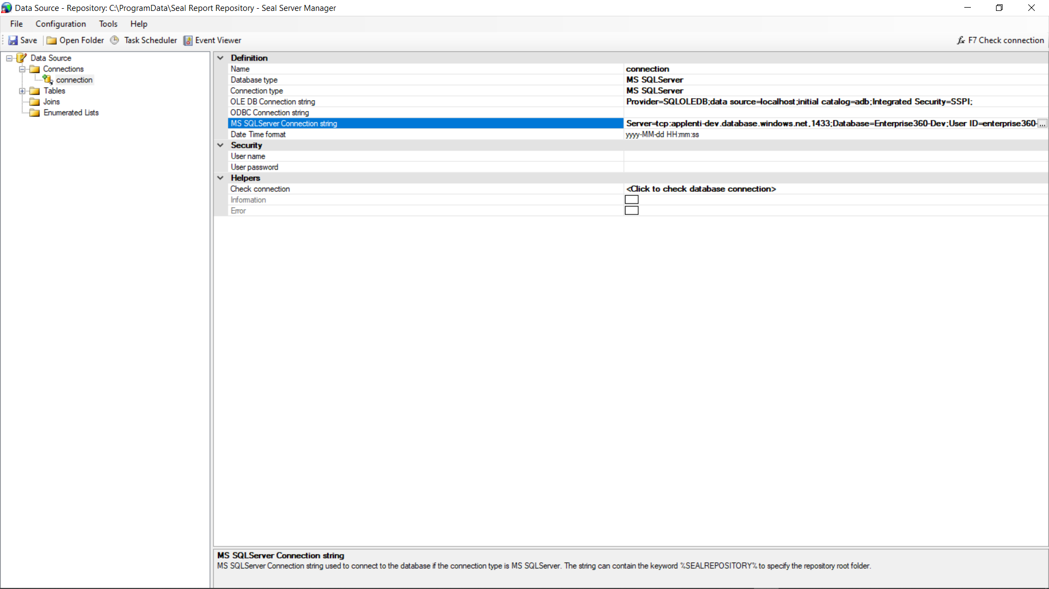

We can check the connection by clicking on “Check connection” present below.

We can add new table or import all the tables present in DB by clicking on ‘Add Tables from catalog’

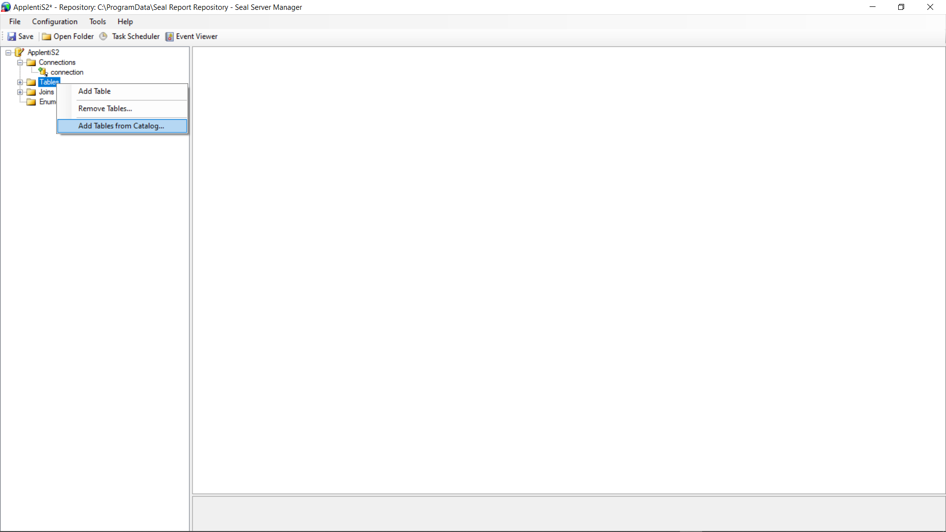

We can also add join or import existing joins by right clicking on Joins

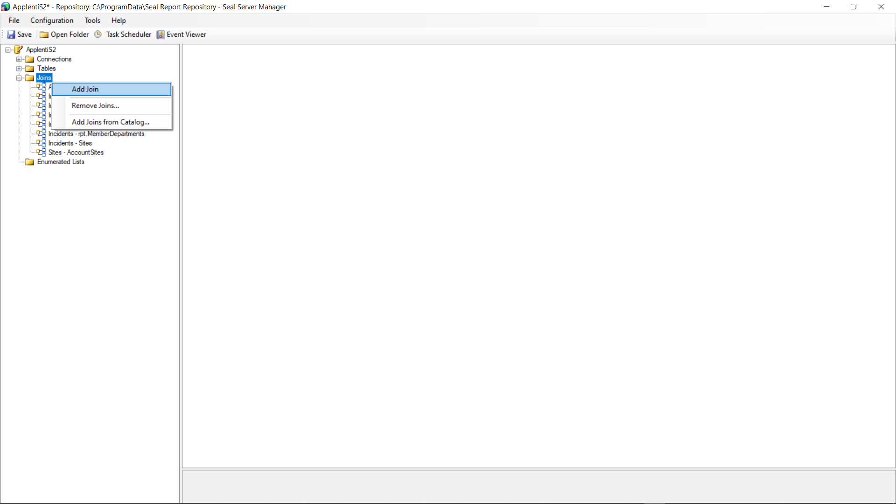

A sample join looks like this. We can specify the type of join in Join type, the tables involved and join clause.

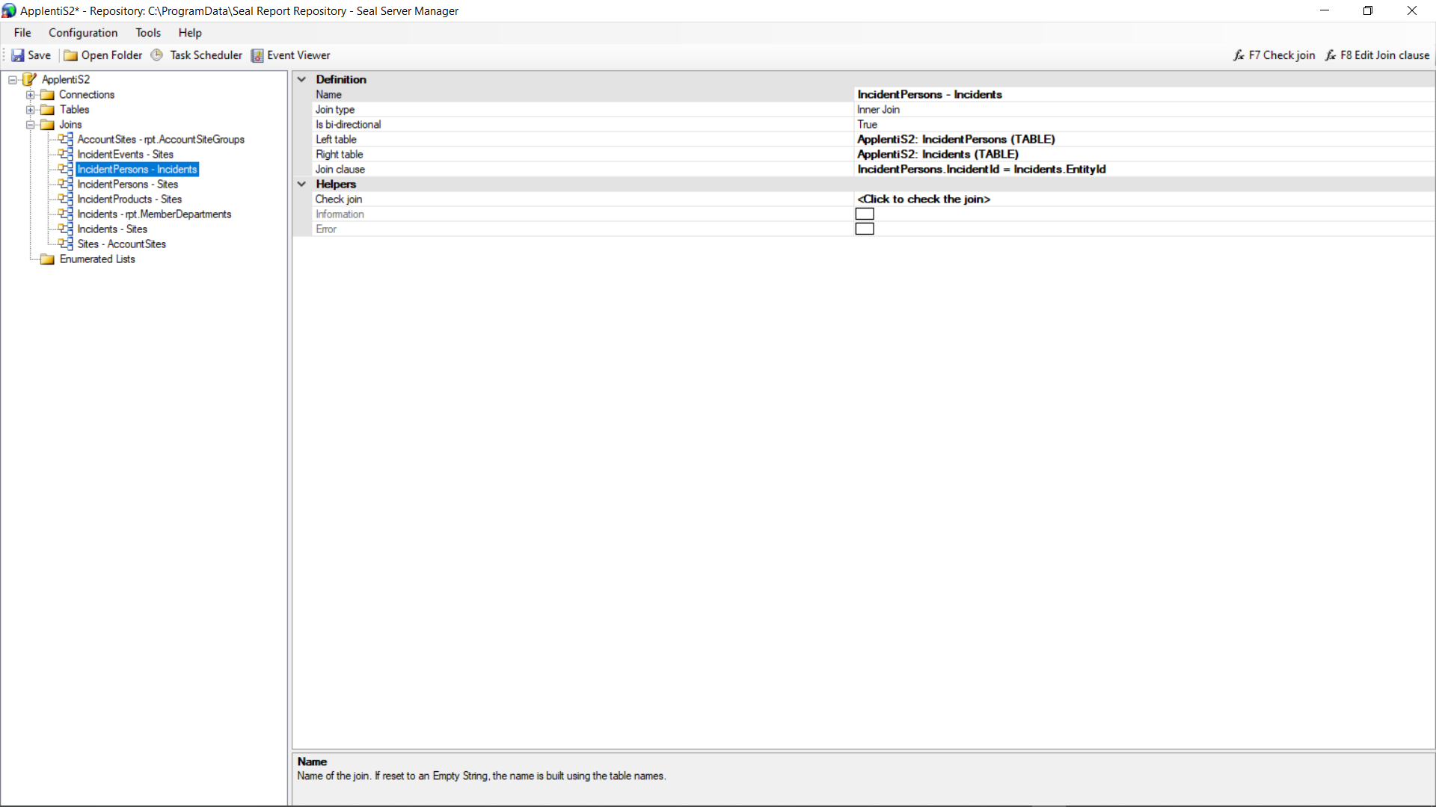

In the Enumerated Lists, we can add a new list in which we can specify the values that we can later use in ‘Columns displayed’ or ‘group by’ etc.

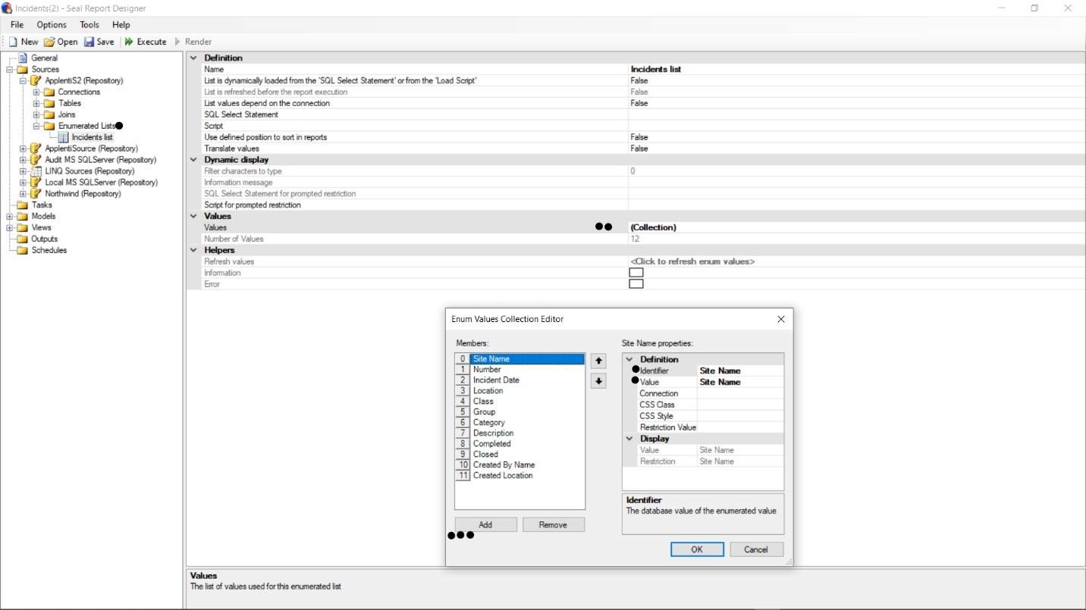

Similar procedure can be followed in Seal Report designer too to create a Source

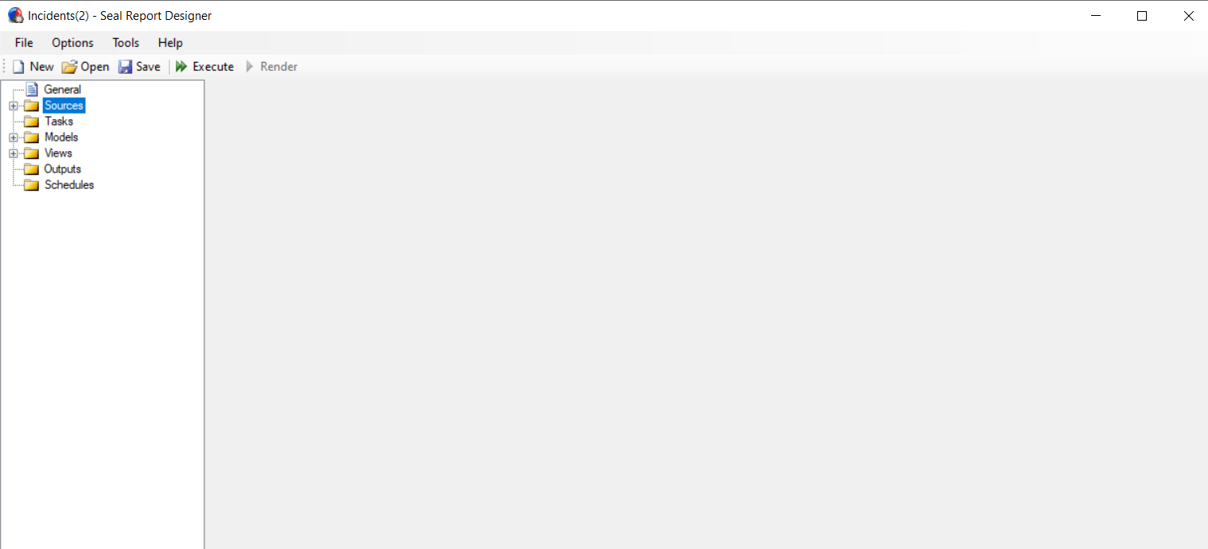

Step 2 – Creating a Model

Right click on ‘Models’ and add the type of model we wish for

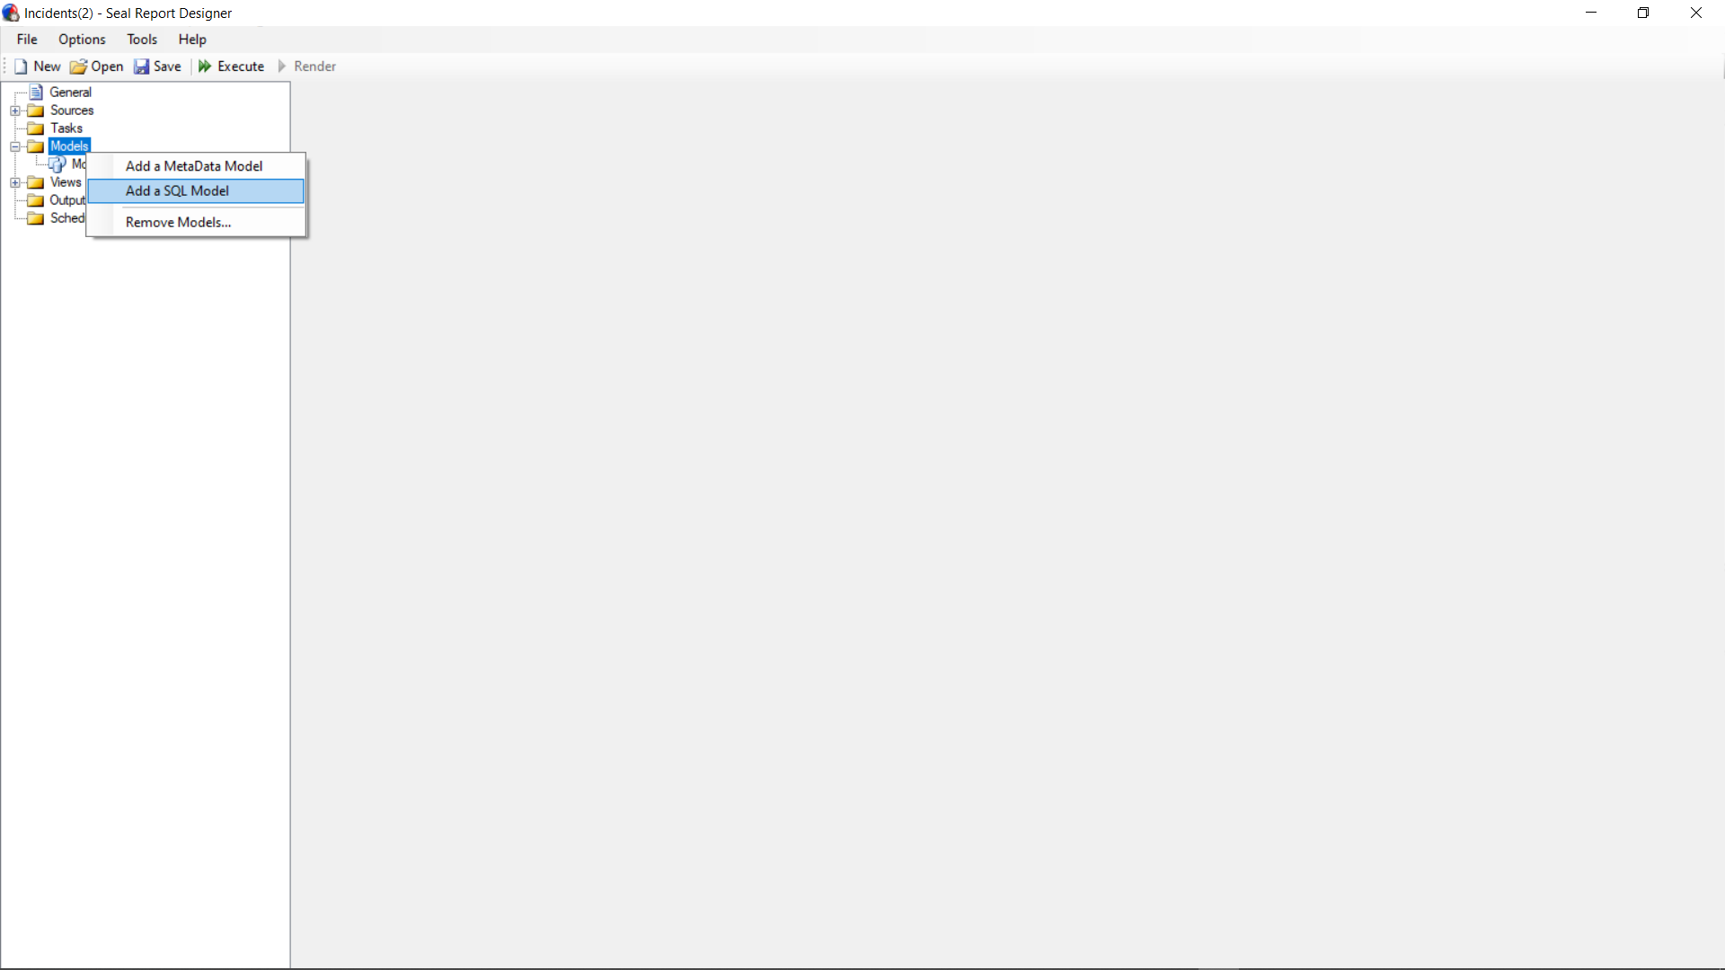

After we create our model, the source and connection that the model is gonna use can be specified in Model Definition part.

All the columns that can be used are displayed. We can drag and drop the columns that we require in the Elements section. Depending on how the report should look like we drop the columns in either ‘Page elements’ or ‘Column elements’ or ‘Row elements’ or ‘Data elements’

We have added a Pre load script and Post load script in the Model Definition section in the concerned places for “Group by” feature

The following are the scripts we wrote

**Pre Script**

* Get the restriction from the model
* Check for the previous group by elements if they exist
* Get the new group by values from the restriction
* Find the difference between these 2 arrays
* Now in the last part here we bring these new group by rows to the front of the schema.

**Post Script**

* First we follow the above approach to find the new group by values
* Then we find the names of these columns in the actual schema
* Using these names we give a sort order to the result
* Finally we iterate over the result data and group elements until we find new values for the grouped columns since it has already been sorted

Below Screenshot is for the Incidents report where all the columns are placed appropriately.

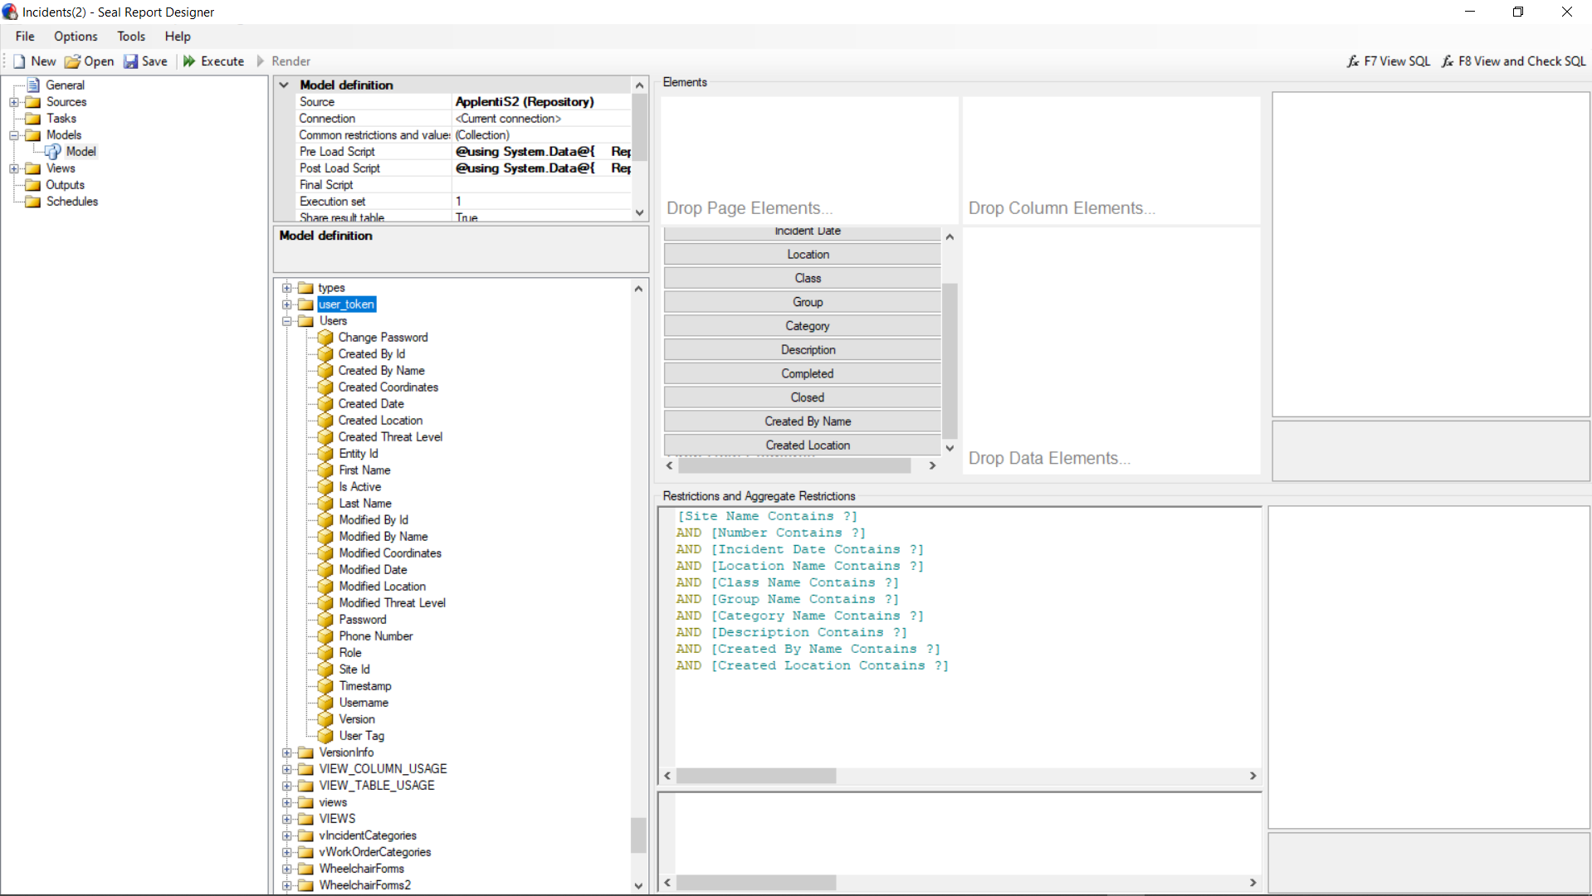

The Restrictions on columns can be added by drag and drop of concerned column in the ‘Restrictions and Aggregate Restrictions’ section.

We can set the restriction like ‘contains’ or ‘equals’ or ‘starts with’ etc. as shown in screenshot below.

Also we can make them prompt at execution time and this basically works as a Filter on that column.

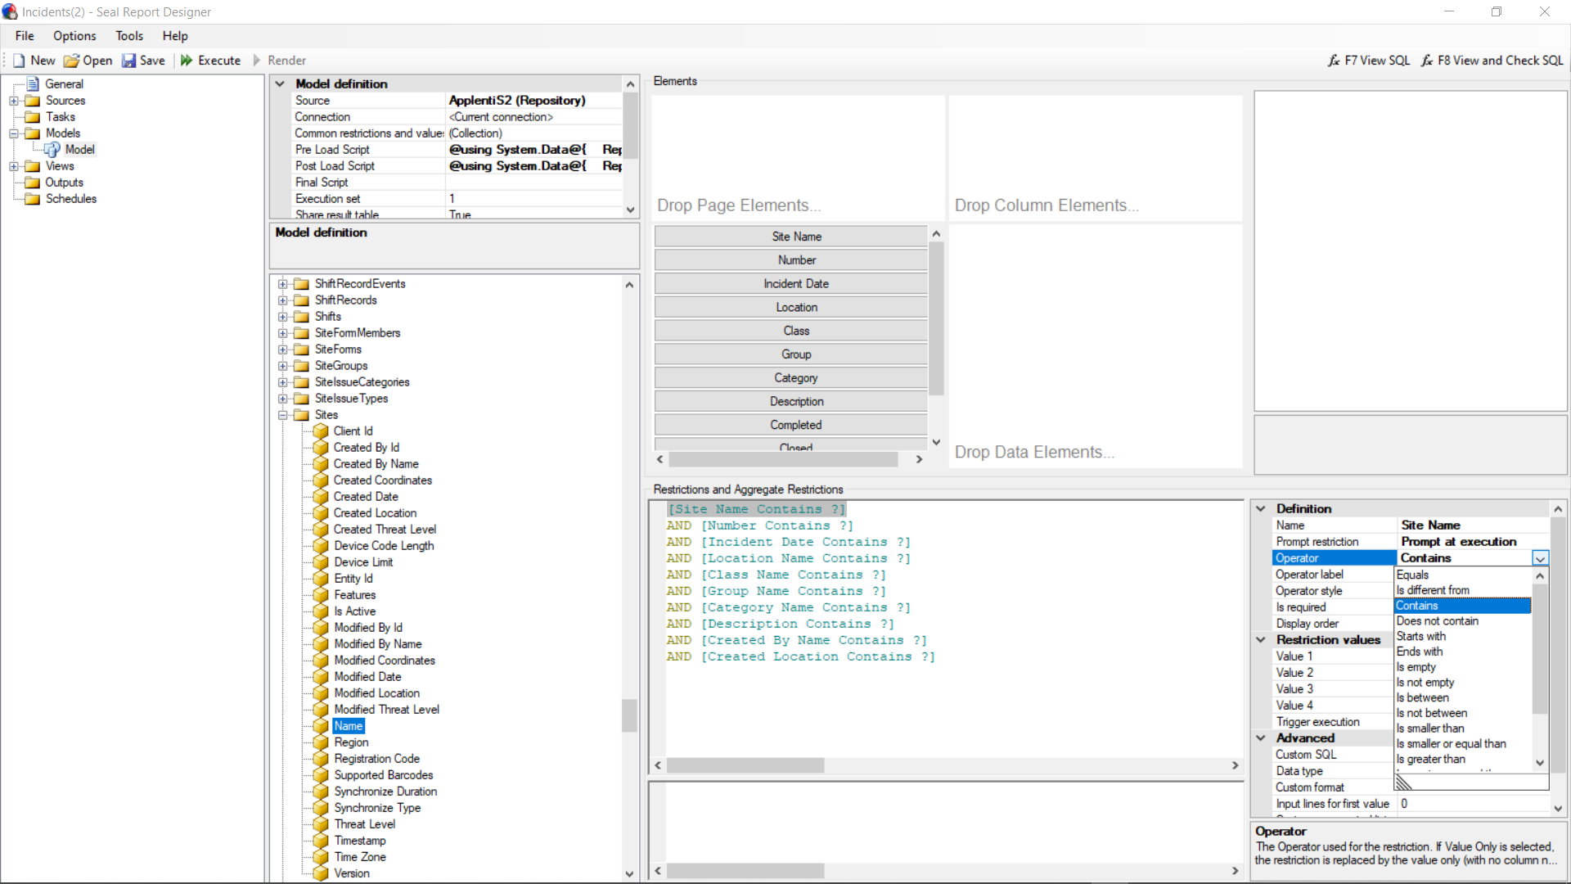

Step 3 – Create a View

Right click on the view to create a view

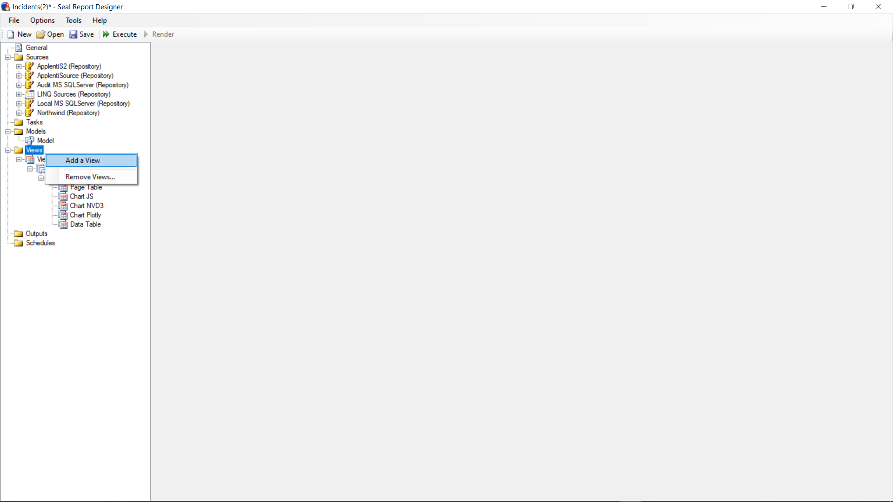

Under View -> Model we can select the model we wish to create view for

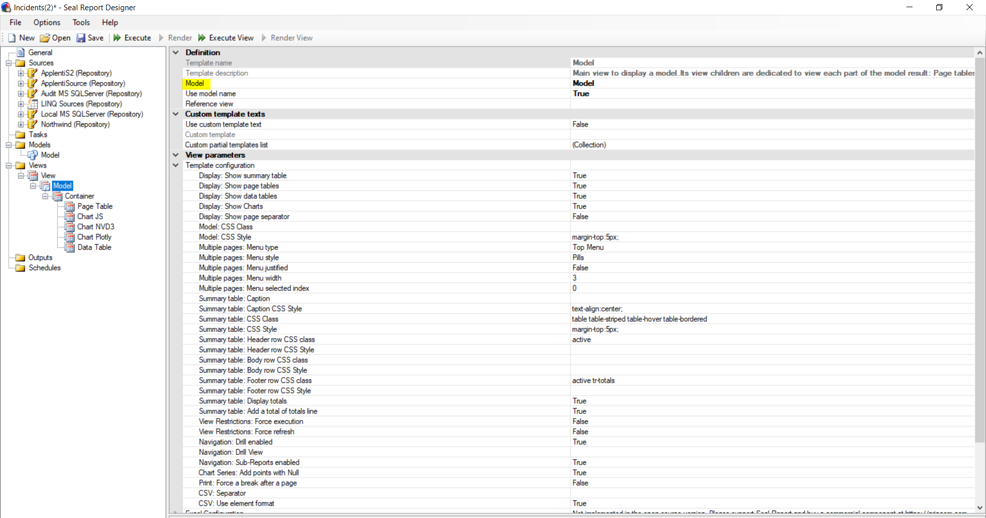

In View if the option Force execution is set to true then the execution is done when the view loaded without clicking on execute button

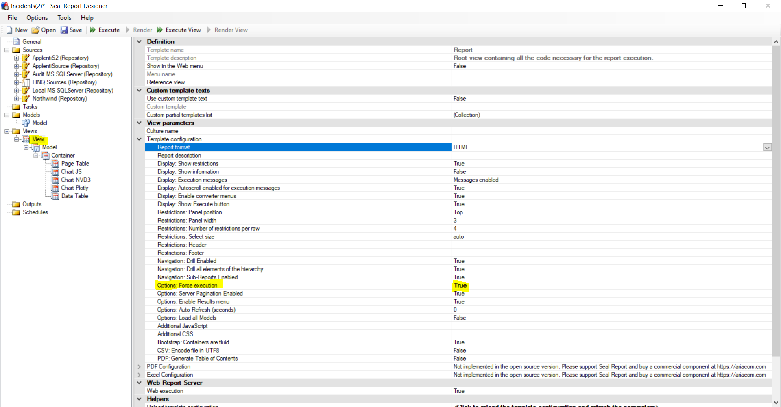

For different views to use some of the common features like ‘columns displayed’ and ‘group by’, We can go to General -> Click on ‘Collection’ under Report Input values -> Add the common elements here.

The values then are set as shown in screenshot.

For the view to load with some default columns, we can select any one of the enumerated lists that we created under ‘Advanced’ -> Custom enumerated list

After selecting the proper list, under Restriction values -> Value -> <Click to edit values> -> here we can select the columns that are used as default when a view loads

By setting the ‘First selection’ to ‘Use selected values’ we will be using only the values that we select and setting ‘Trigger execution’ to True makes sure the view loads/refreshes whenever a new value is selected.

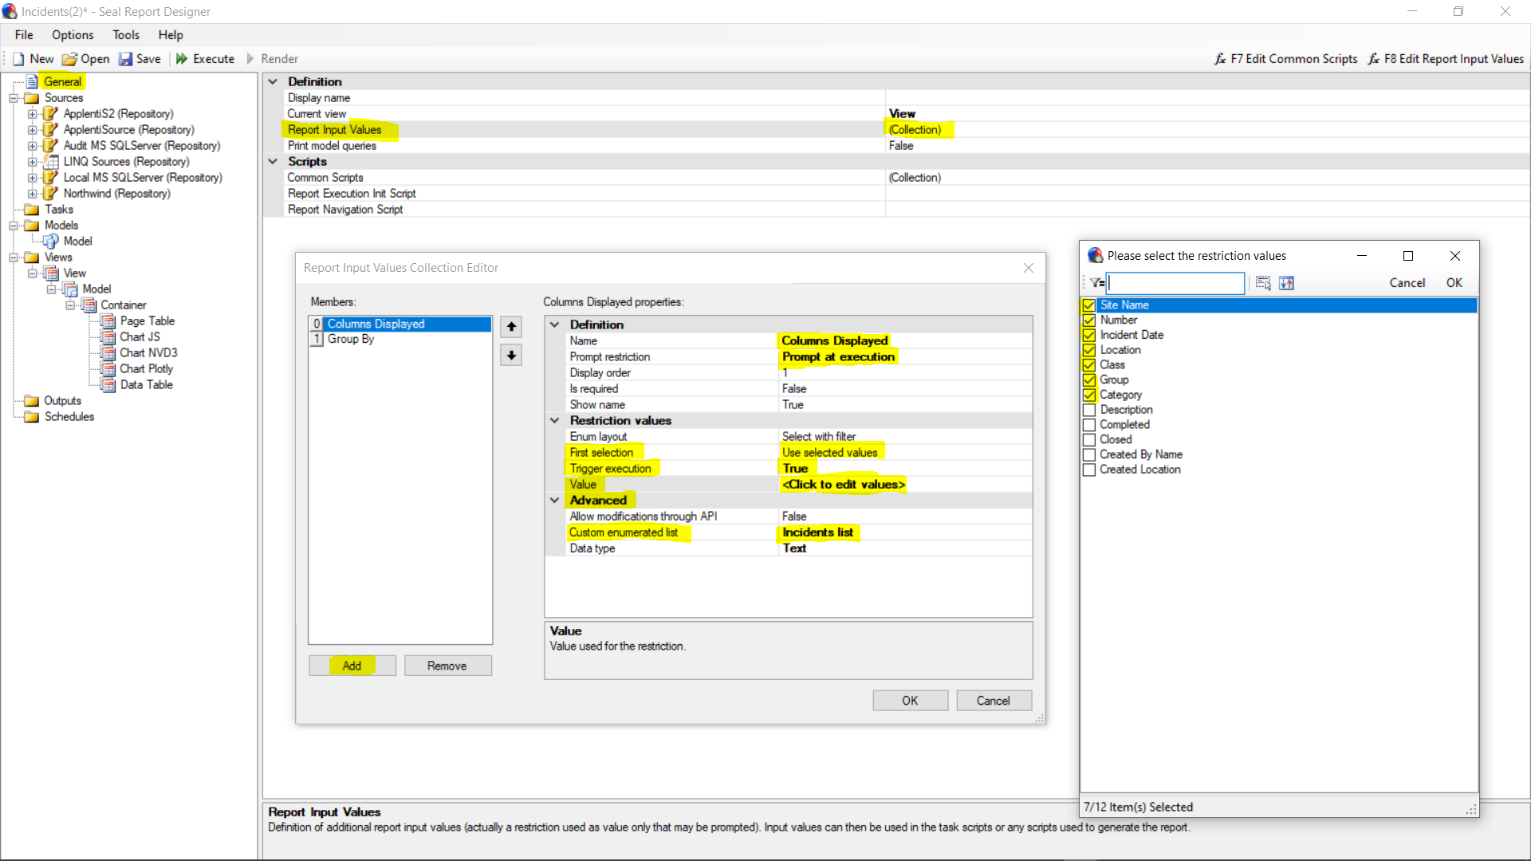

Drill down –

In the incident report, if we hover over the incident no, we can see a drill down option to view the ‘information’ related to that incident

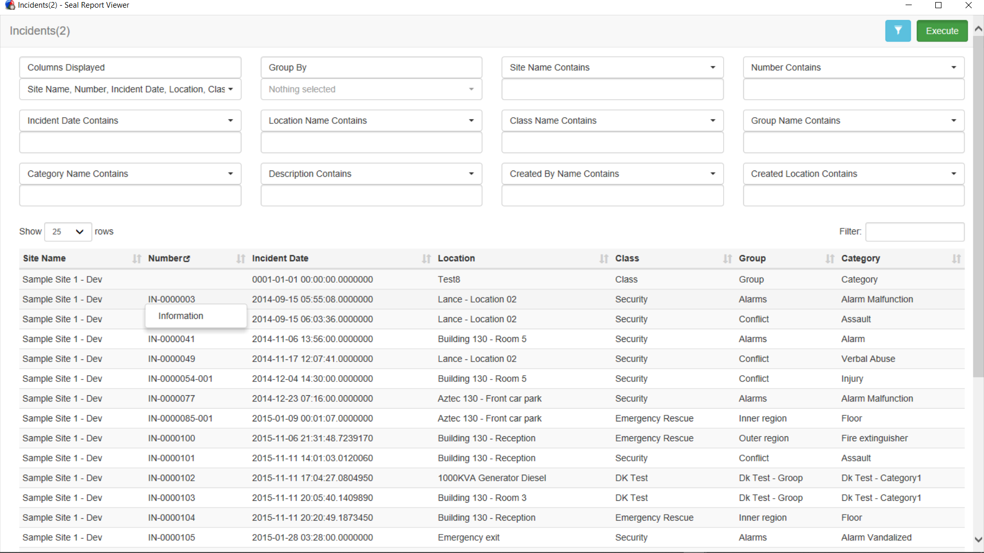

This is done as shown below

In the model that we created, if we click on the columns that we dropped the elements section then that shows us the table under which the column is actually chosen from. In this case the Incident number column is chosen from the table Incidents, which is highlighted in blue when we click on Number

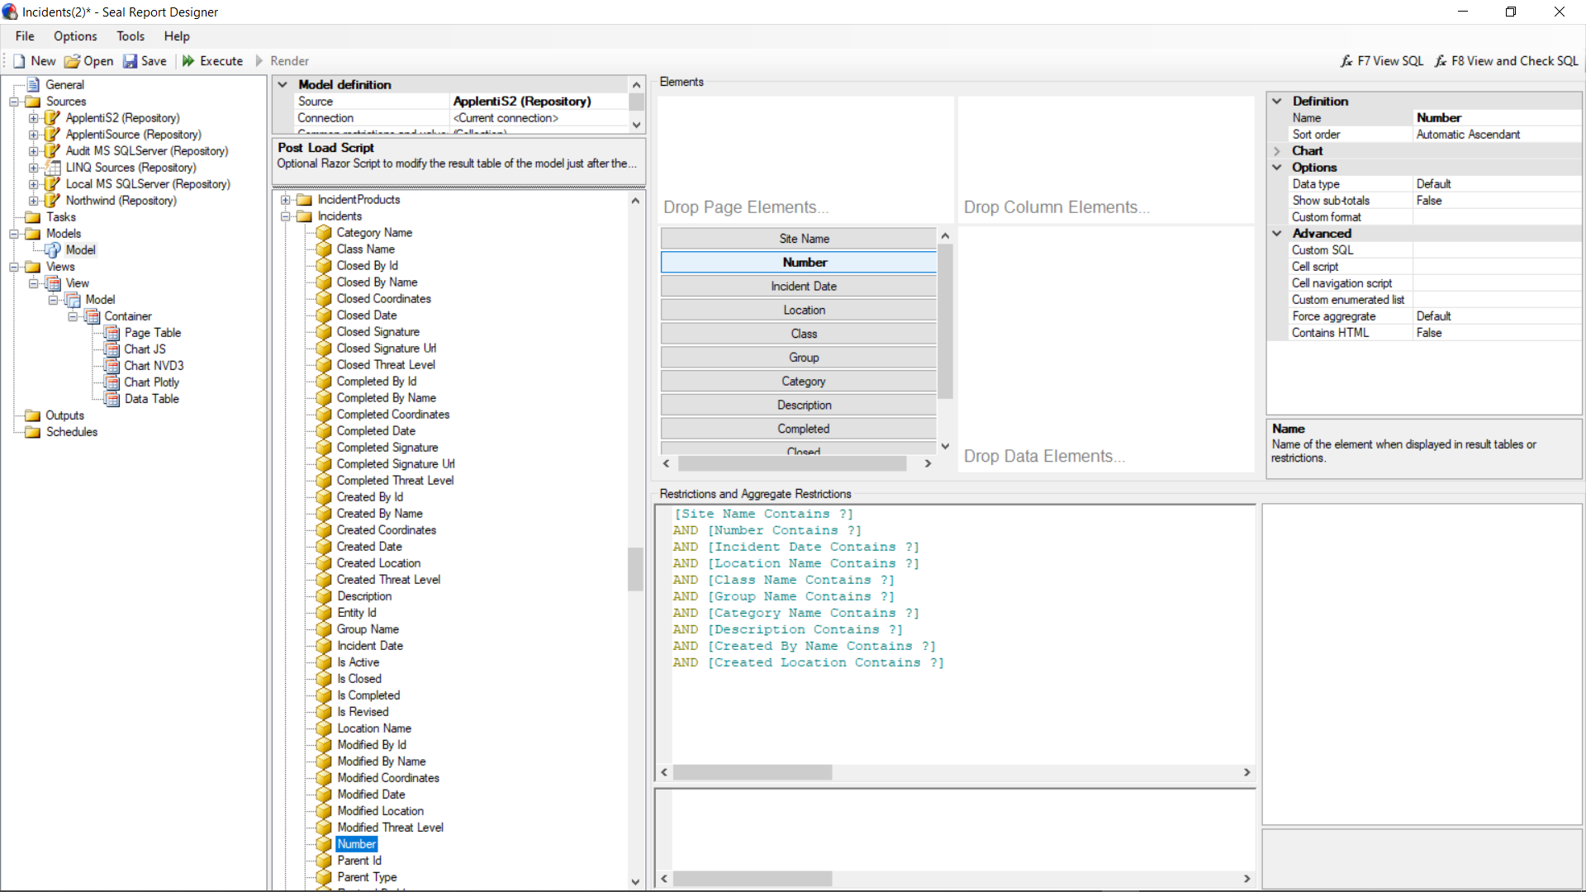

Right click on the column and click on ‘Go to Source Column’

This takes us to the data source under which the table of the selected column exists

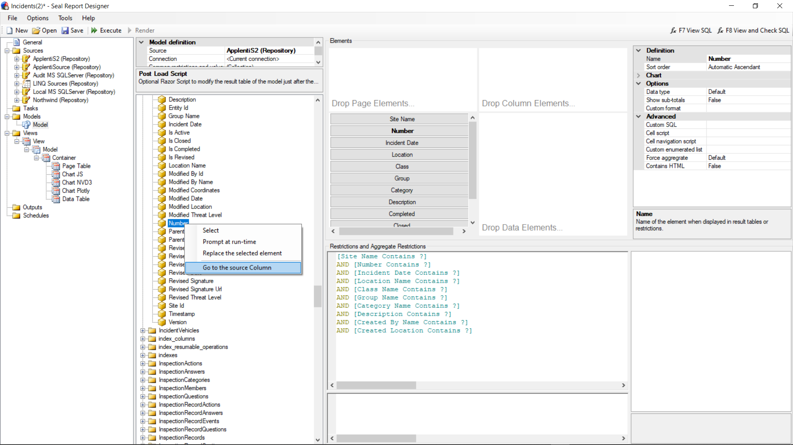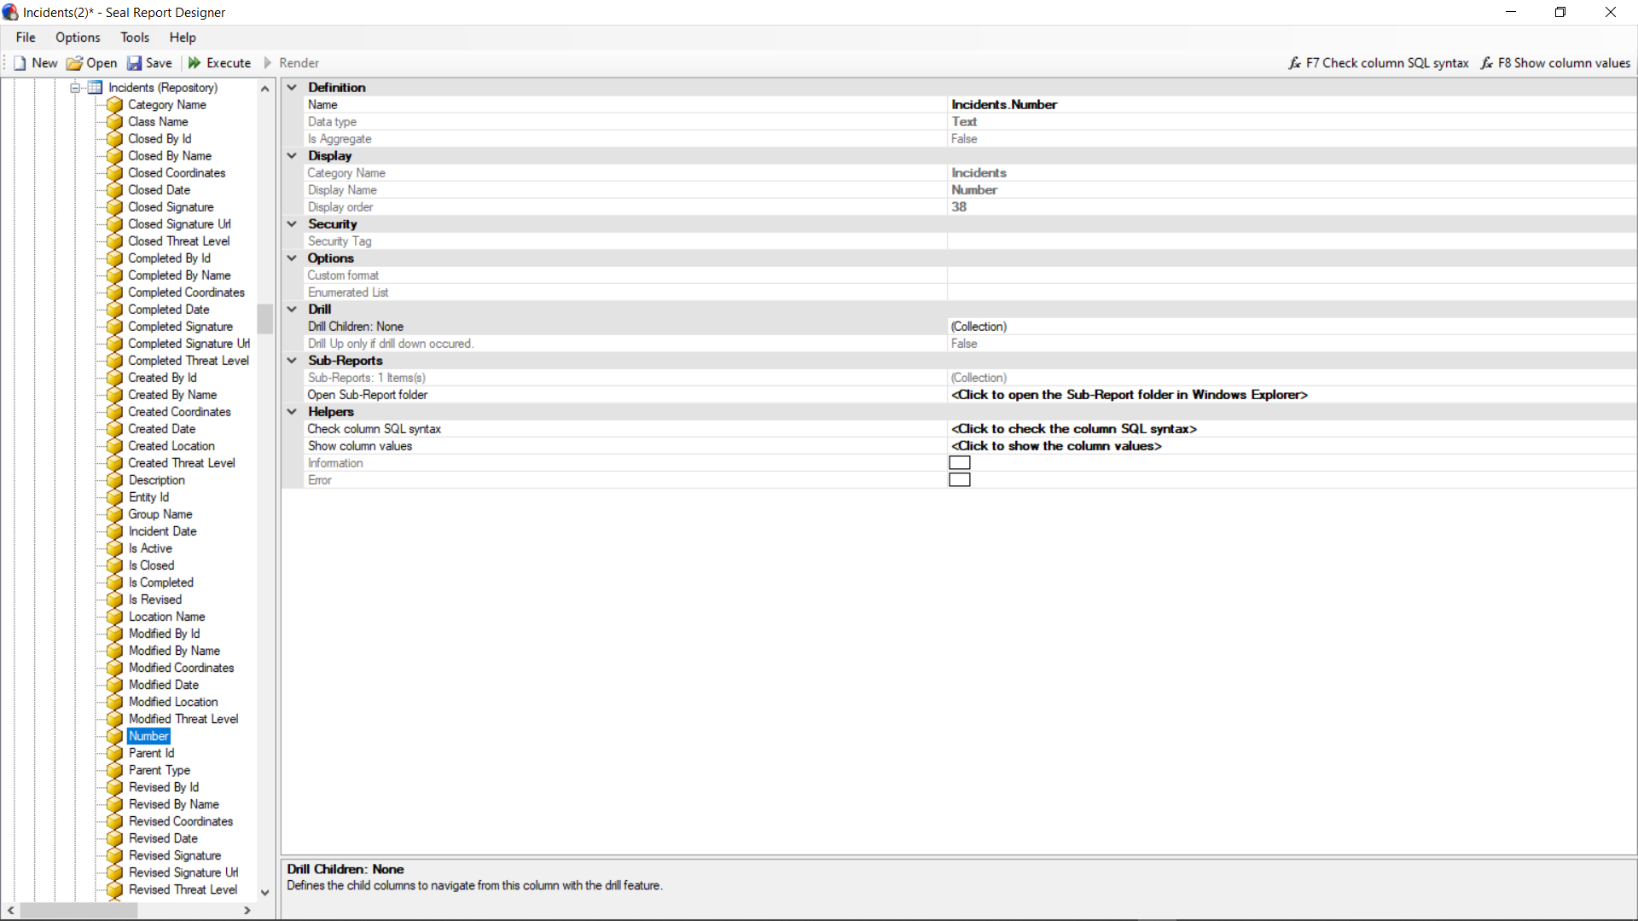

So to generate a sub report when we click on the ‘Information’ that we see in our view, we have to add a ‘Sub report’ under ‘Sub reports’ as seen in above screenshot. This is done in Server manager

In Sever manager -> open the data source that we created -> go to tables -> Incidents -> Number

Here we can just attach the report we want to be shown when we drill down in to the Incident number of our previous report. This is done by creating another report and adding it under ‘Sub-reports’ -> Add an existing sub report -> and in this case it is the ‘Information’ report.

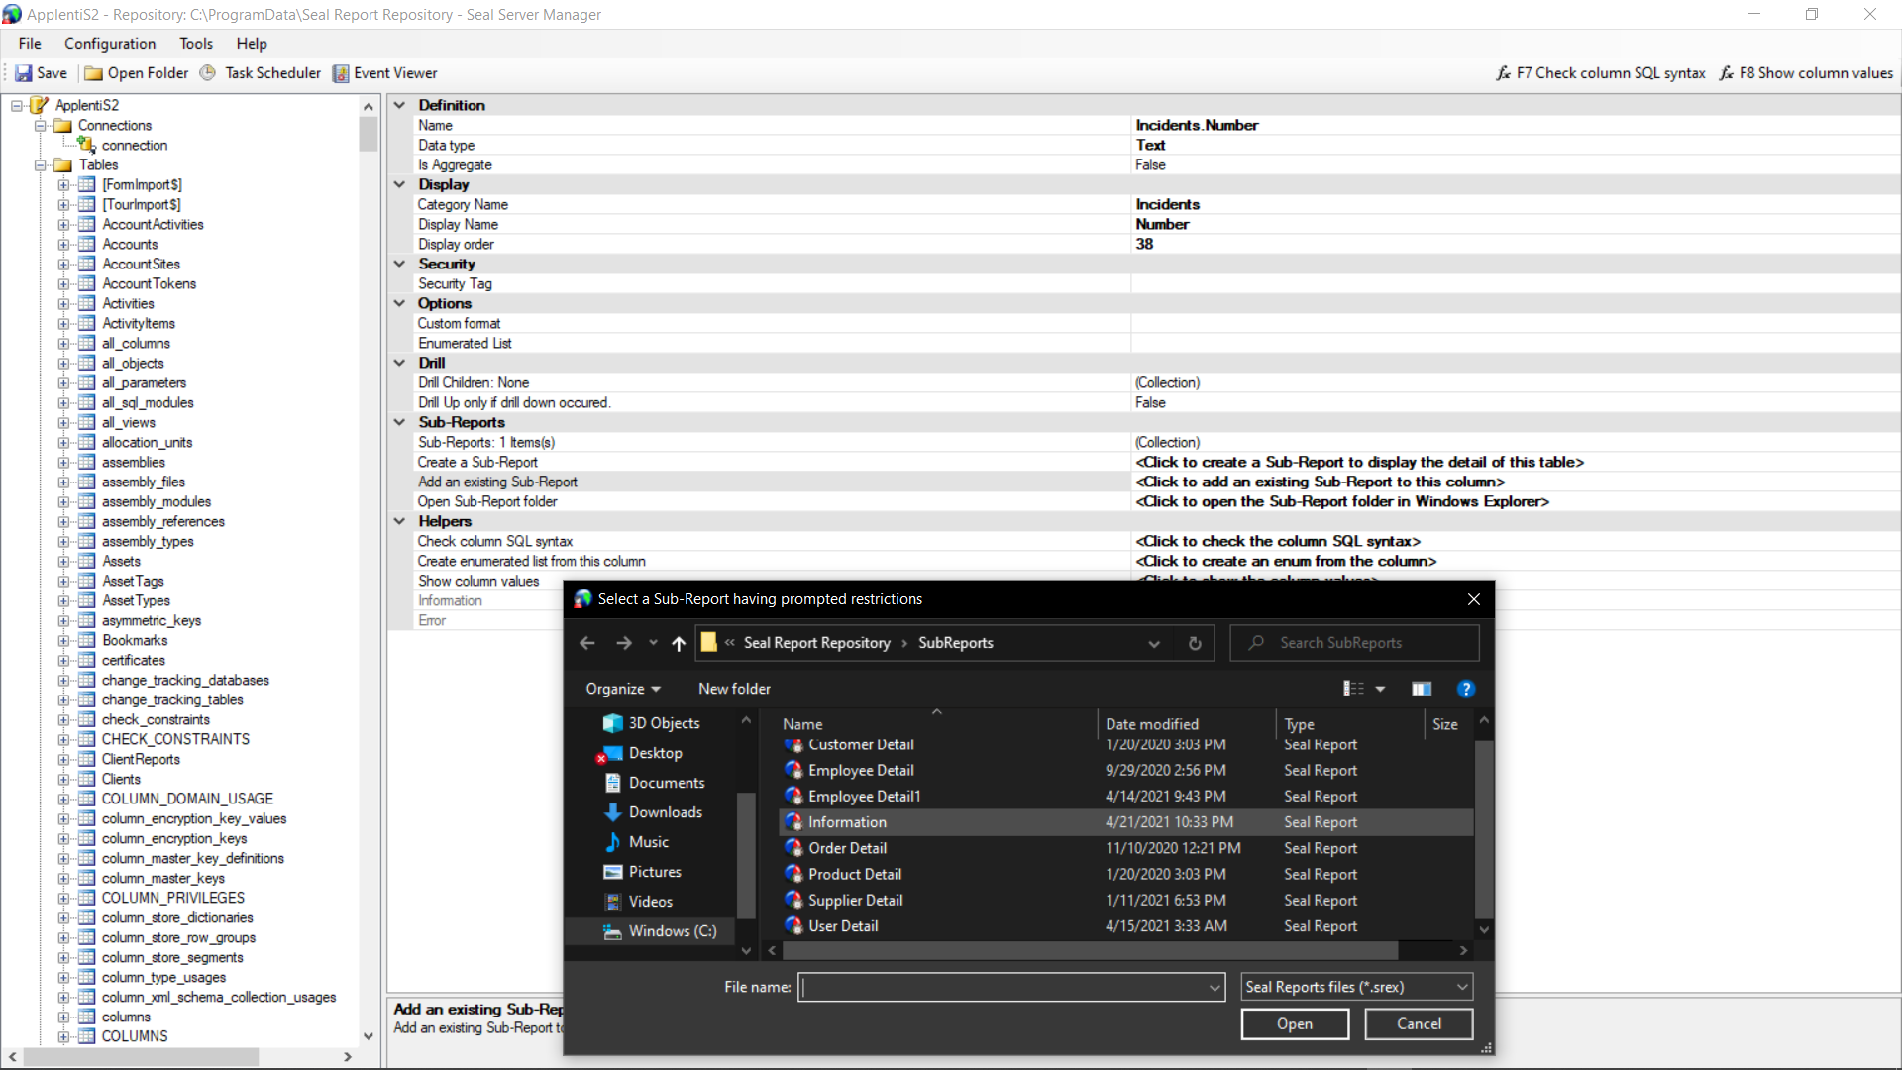

The Information report which is our sub report looks like this i.e. the model looks like this

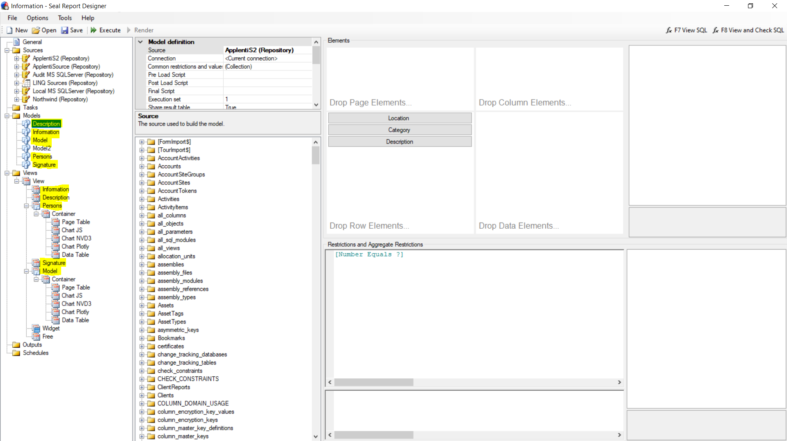

As the sub report contains a number of views combined in to 1 report, different models are created under Models and under Views -> view -> Different types of views required to generate a report are placed.

The following report is generated when we click on Incident number -> Information of our report

